How to Access Your Course on EZ Class

1. Go to www.EZClass.us. Click the Log In button.
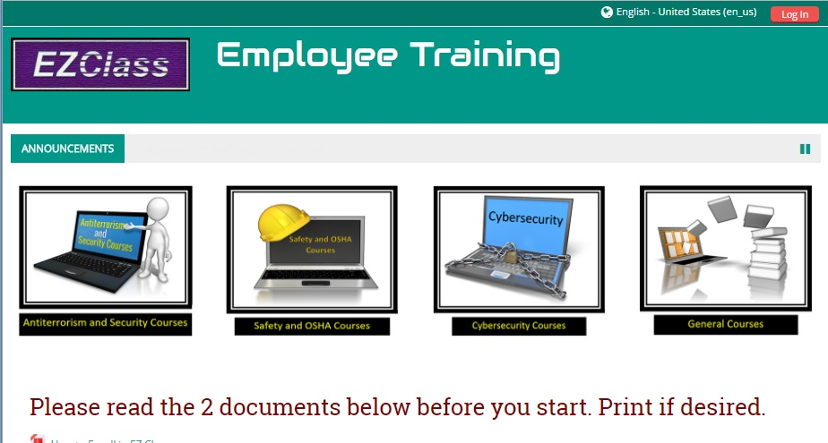

2. Type in your Username and Password.
a. Your Username is always the first letter of your first name, followed by your complete last name. For example, employee John Smith will have the Username of jsmith. Usernames are ALWAYS in lower case letters.
b. Your temporary Password is the word bus (lower case). Once you log in the first time, you will be prompted to change it (Step 3).
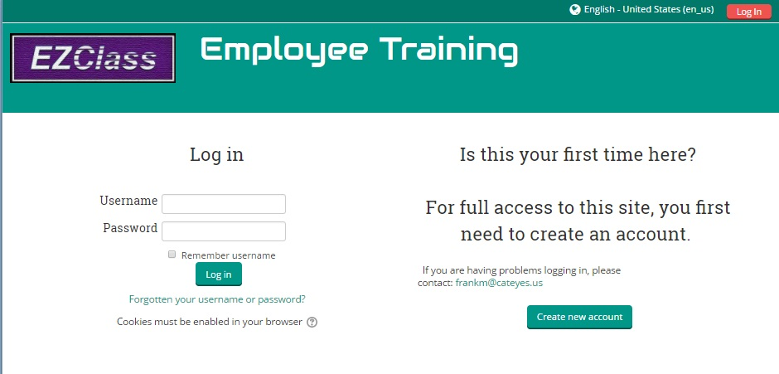
3. Change your Password. Minimum of 3 characters, no other restrictions. Remember, your “Current password” is bus.
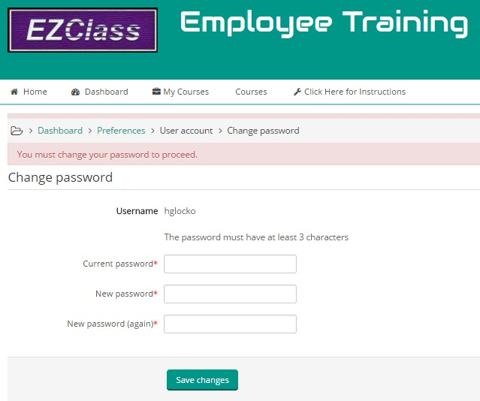

4. Follow the prompts.
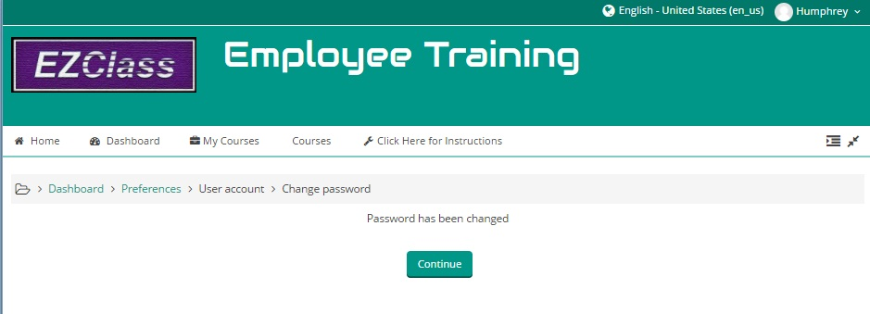

5. You have been enrolled in a Security Course. Click the appropriate box.
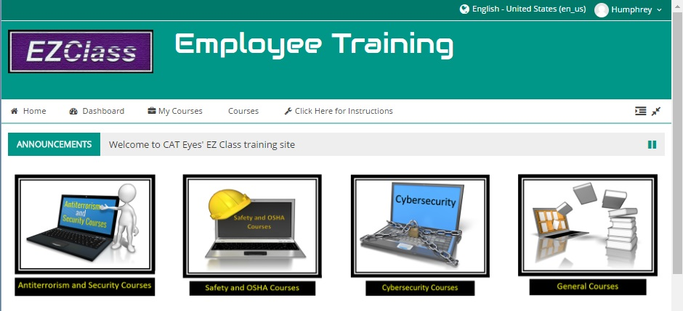

6. Choose (click) on the course, “Academy Bus 1-Hour Security Training”.
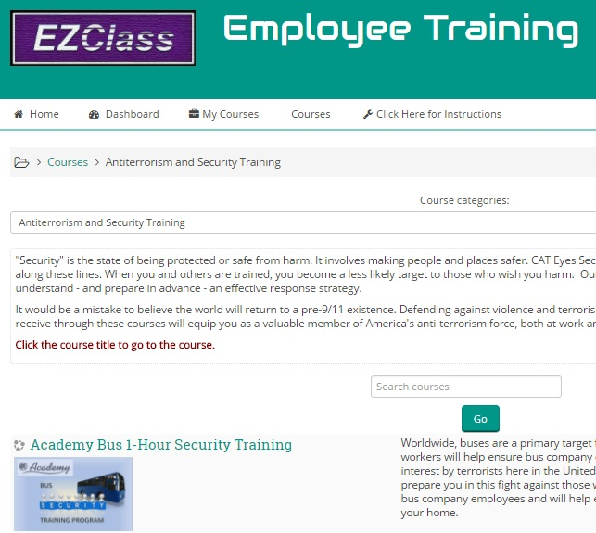

7. Open the course, “Academy Bus 1-Hour Security Training”.
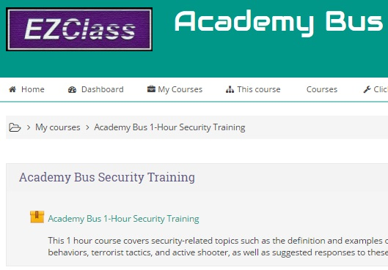

8. Enter the course. The presentation will start automatically.
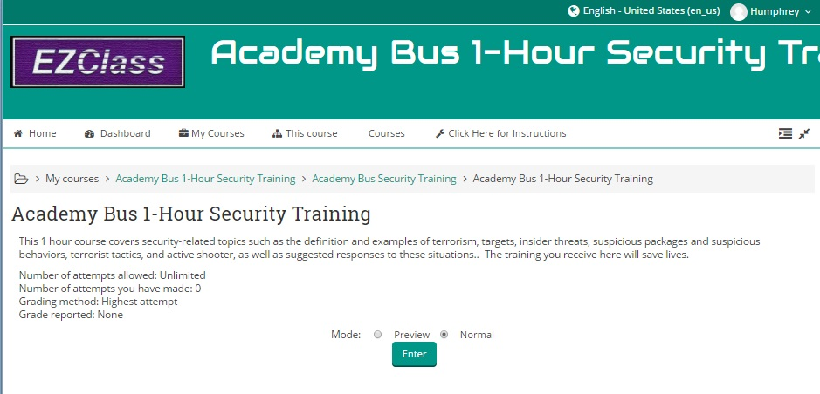

If you need assistance, email Frank@EZClass.biz or call 609-448-9655

