HOW TO UPDATE YOUR ACCOUNT INFORMATION IN EZ CLASS (including change of email address)

Step 1: Go to www.EZClass.us and Log In.
NOTE: You have the option to retrieve your Username or Password if you forgot them – it’s below the
Log in
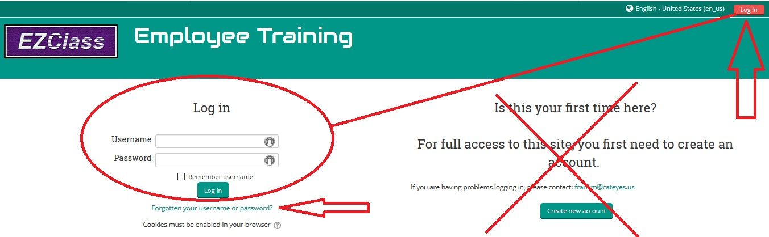

Step 2: After you have Logged In, click on the “v” next to your name to reveal the drop-down box. Click on “Edit profile”
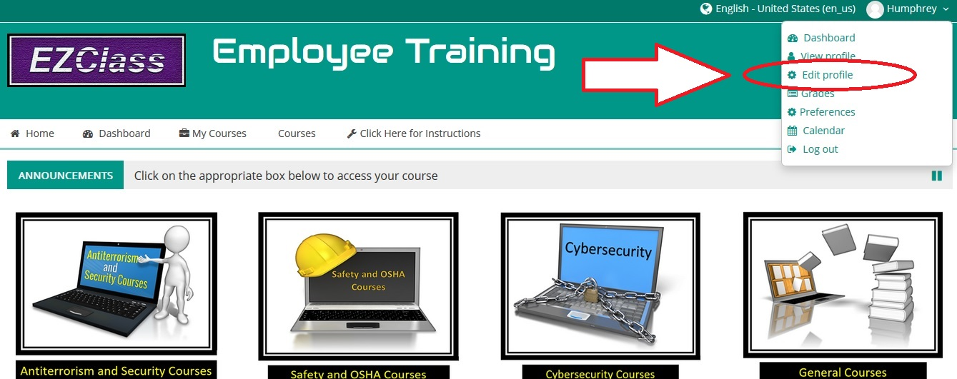

Step 3: The following box will be revealed. Make any necessary changes, including the email address you want on file with us. You can add other information if you wish.

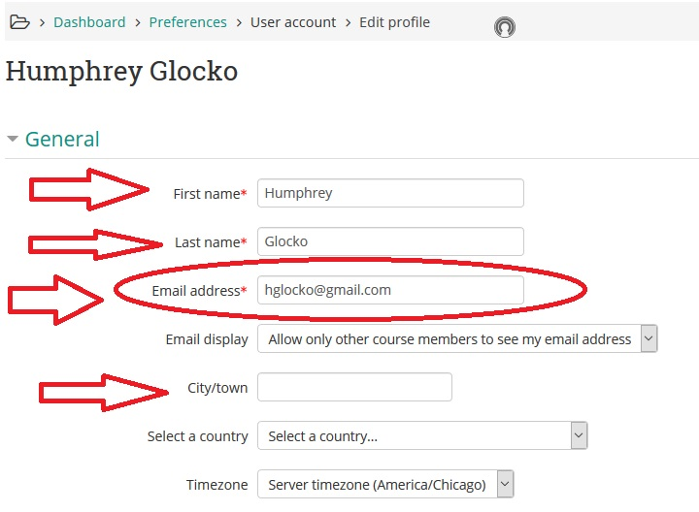

Step 4: When finished, scroll to the bottom of the page and click the “Update profile” button to save your changes.

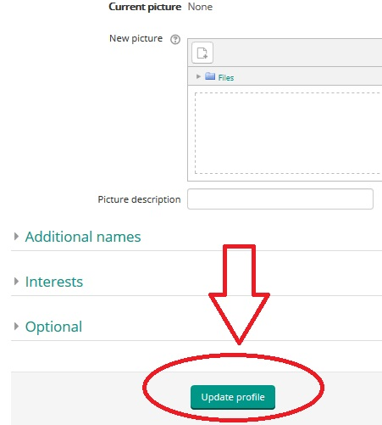

If you require further assistance, contact the EZ Class Help Desk at (609) 448-9655 or email frank@EZClass.biz.
